**Report**

The goal of this project was to develop a system that accurately detected pedestrians and vehicles from an image and estimated the distance to these objects. I made use of object detection through YOLO, and implemented two approaches to stereo vision: dense and sparse. I consider the dense approach my primary solution, with sparse being an alternative approach to reach the same conclusion.

**My Solution – Design Choices**

Some improvements to the initial integration of dense stereo vision and YOLO:

**Histogram Equalisation**: Illumination in the provided dataset was an issue, so an attempt to reduce this before calculating the disparity map was made. I used CLAHE to do so – an advanced histogram equalisation method.

The contrast of the CLAHE image is improved, making the image sharper and darker regions more visible.

**Image** – without CLAHE applied

**Image** – without CLAHE applied

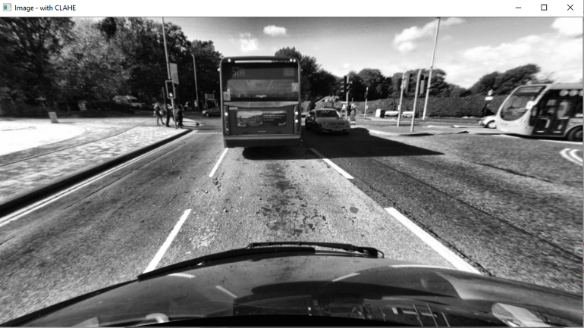

Fig 1b.

Fig 1a.

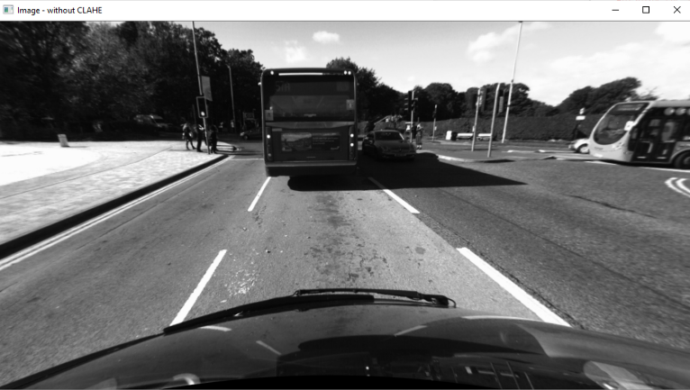

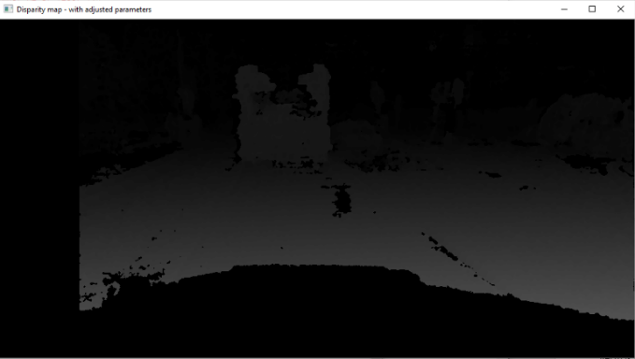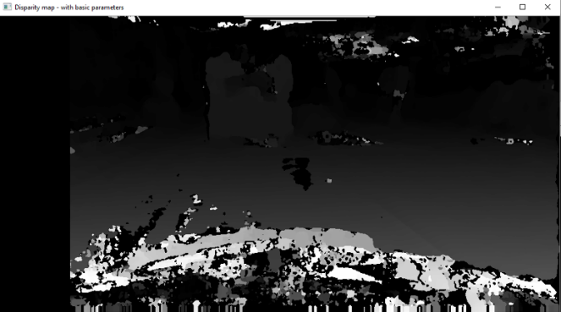**Stereo_SGBM parameters**: Adjusting the input parameters for the SBGM object was critical in producing an accurate, but somewhat noiseless, disparity map. Many parameters allowed for the removal of later functions calls – e.g. filterSpeckles was integrated into the object itself through several of its founding arguments.

Fig 2b.

**Disparity map –** no adjustment to parameters

**Disparity map** – adjustment to parameters

Fig 2a.

**Calculating distance**: For each object a Gaussian kernel was generated (based on the size of the object detected). A matrix of disparities was then taken from the image of the same size, centred on the central pixel location. The convolution of this matrix with the kernel is then performed, from which distance is calculated.

Much testing showed that altering the size of the kernel was critical to determine correct distances. Further objects would display poor distances or the time to calculate would significantly increase.

Despite the similarities in the examples below, I found the **Gaussian kernel** approach to have the best consistency to accuracy ratio. Other variants typically had decent results, however, would produce inconsistent or inaccurate values far more regularly.

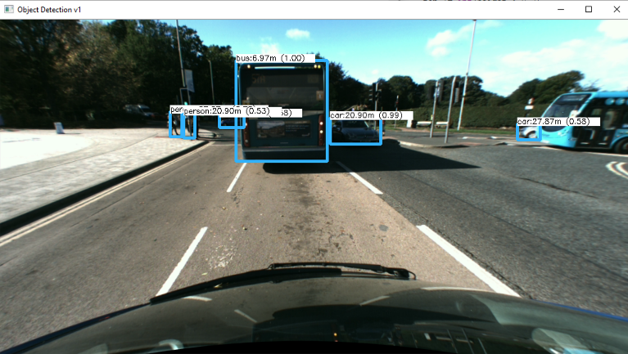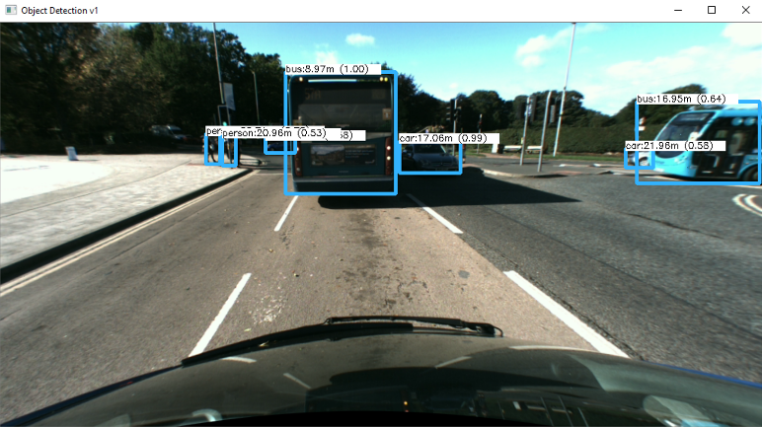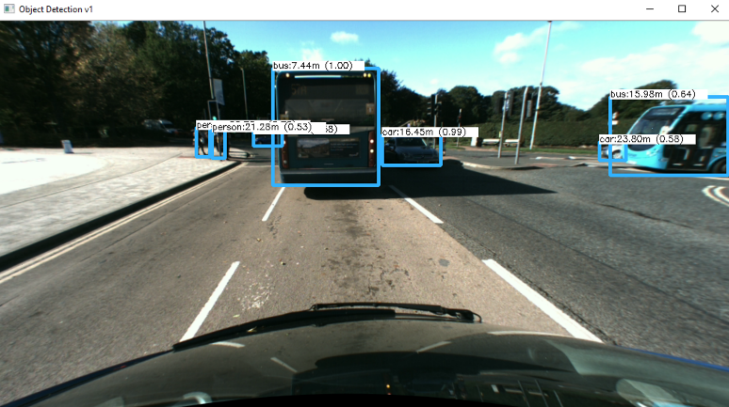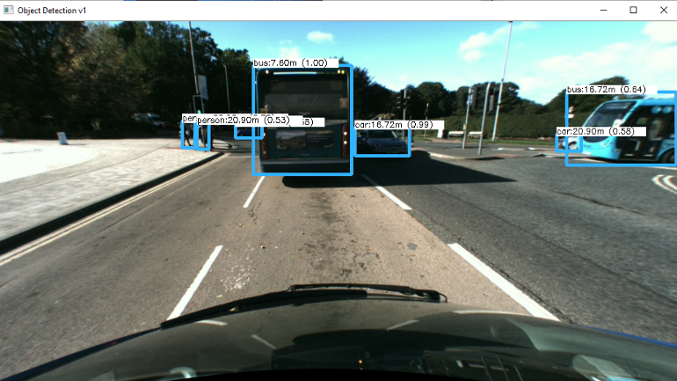

Fig 3a. Averaging the disparities

Fig 3b. Gaussian kernel

Fig 3c. Median filter

Fig 3d. Central point

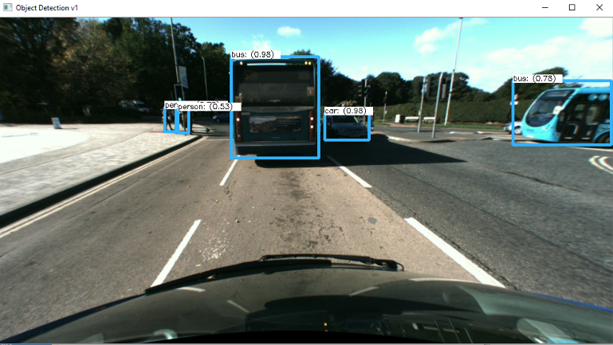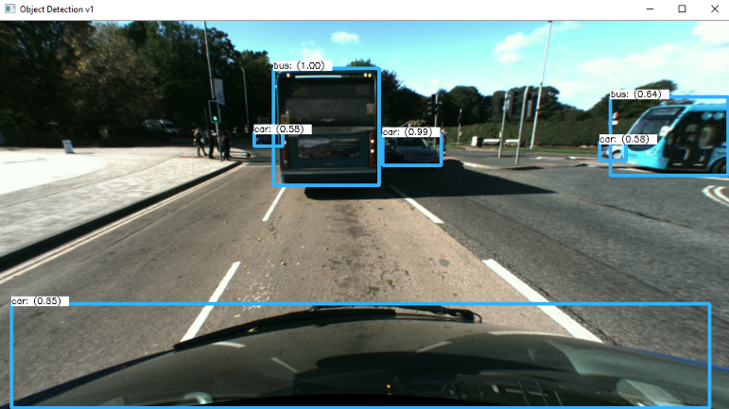**YOLO edge detecting**: In an effort to detect more objects (primarily pedestrians) a simple edge enhancing technique was developed. A kernel was generated (for edge detection) and the image was filtered with this. Previously undetected objects were detected, however, some previously detected objects weren’t. To solve this, YOLO is performed on two images and the objects that appear twice are filtered out.

Fig 4a.

YOLO on edge enhanced image

YOLO on normal image

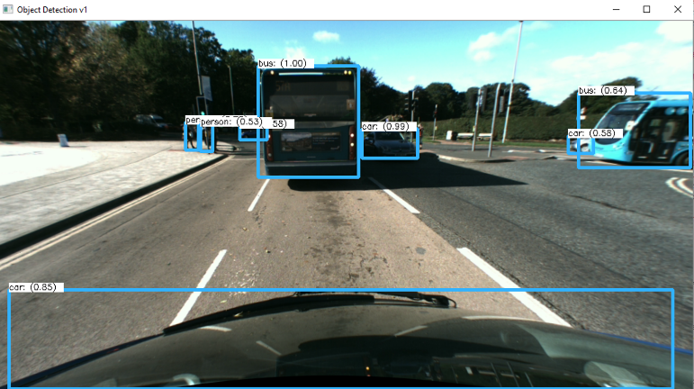

Fig 4b.

The downside that comes with this solution is a decrease in computational speed. If given more time and resources this would’ve been something that could’ve been improved.

Result of combining the objects detected on each image

Fig 4c.

Some changes that proved less effective:

**Weighted least square (WLS) filter**: The use of the WLS filter along with the use of a left-right-consistency based confidence was attempted to improve the quality of the resulting disparity map (through ‘filling in the holes’). The hope here was a smoother, less noisy disparity map would subsequently improve distance calculations. However, found that the removal of noise also removed much useful information from the map, with this causing a decrease in 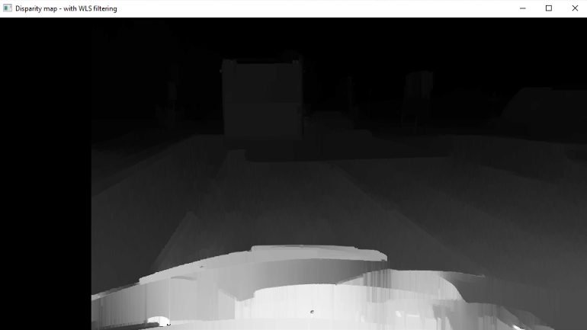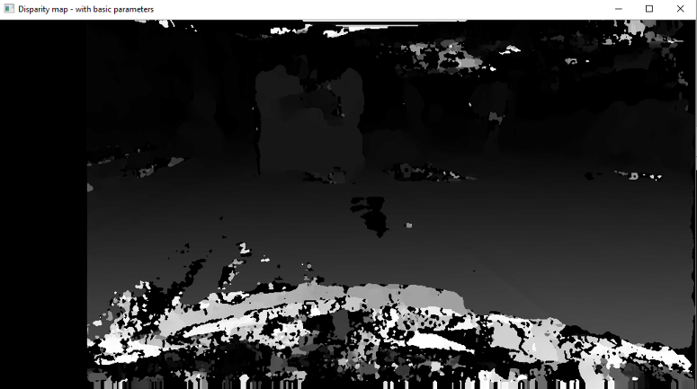the accuracy of many object distances.

**Disparity map** – with the WLS filter applied

Fig 5b.

Fig 5a.

**Disparity map** – with no parameter adjustments (as shown previously)

**My Solution – Analysis of correctness**

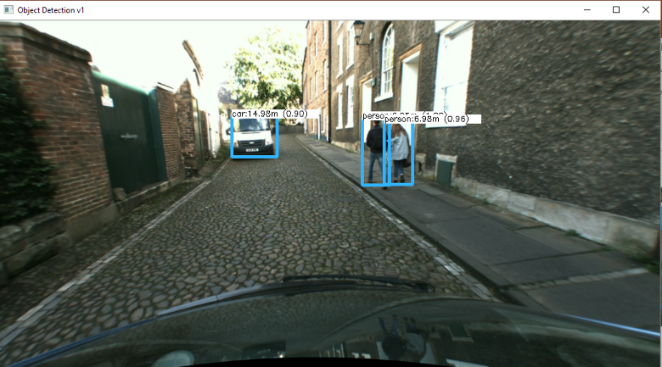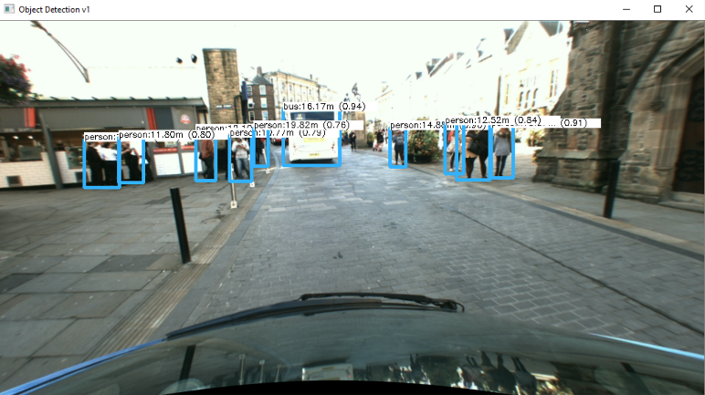The below images are a random selection of images from the test data. They demonstrate below show the solution identifies the required objects within the scene (pedestrians and vehicles), draws boxes around them and displays a corresponding distance with each box

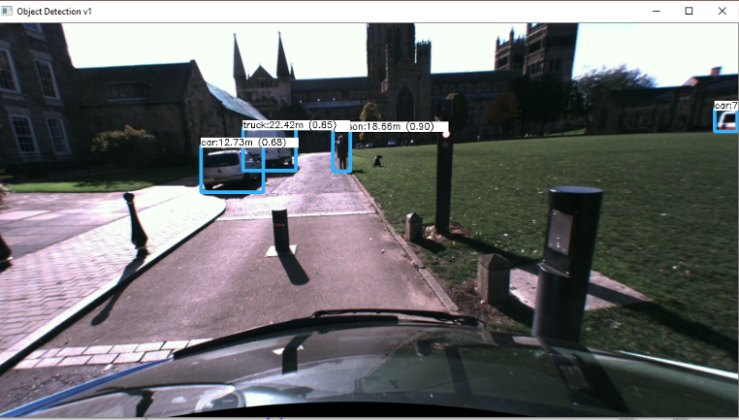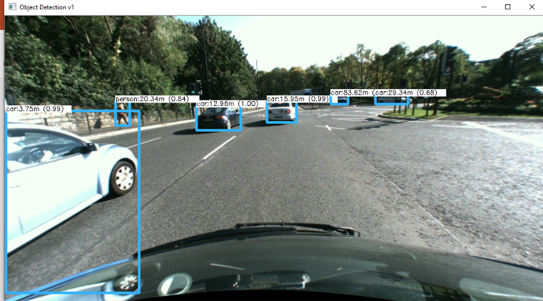

Fig 6b.

Fig 6a.

Fig 6d.

Fig 6c.

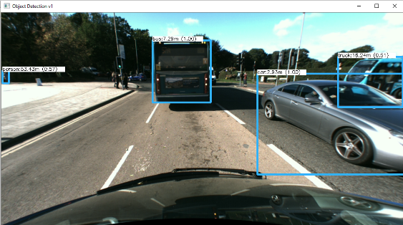

**Additional**: Fig. 6e demonstrates the solution deals with obstructed objects – it still detects the bus.

As well, all Fig. 6a demonstrates it can deal with crowded objects and noise on vehicles (see the bus)

Fig 6e.

Proof of correctness

In order to measure the performance of the solution a random sample of images was taken and the accuracies of the detection and distances were measured. Many online tools such as Google Maps were used to gather correct distances. The images represent the distances correlating to some of the previous figures.

Google maps data for Fig. 6b:

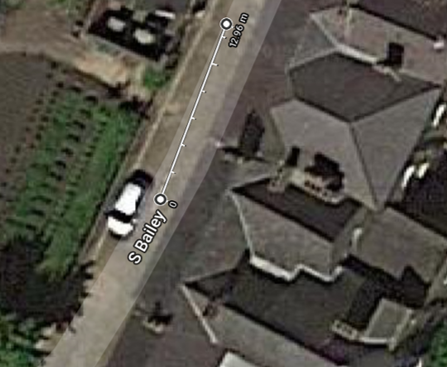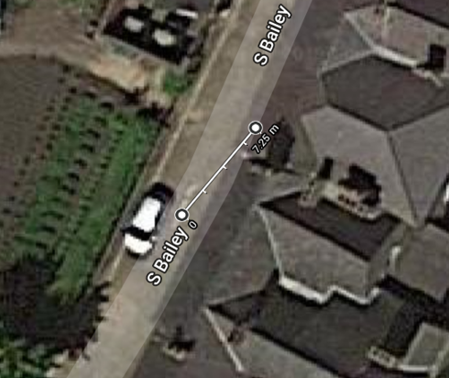

Fig 7a.

Fig 7b.

Fig 7e.

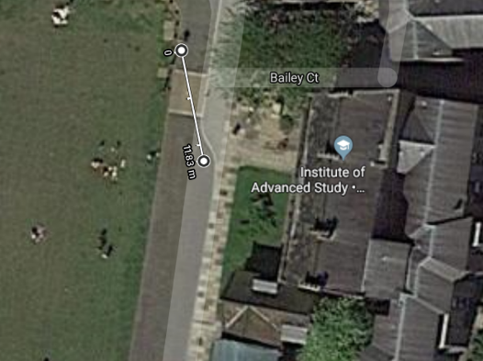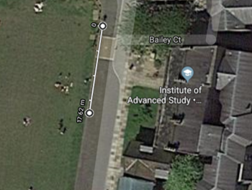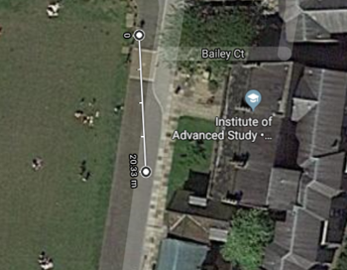Google maps data for Fig. 6c.

Fig 7c.

Fig 7d.

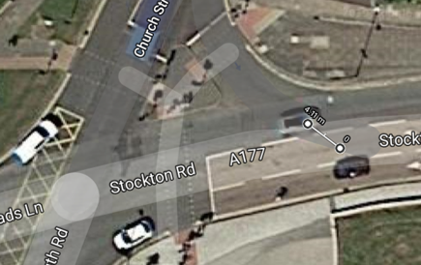

Google maps data for Fig. 6e

Fig 7f.

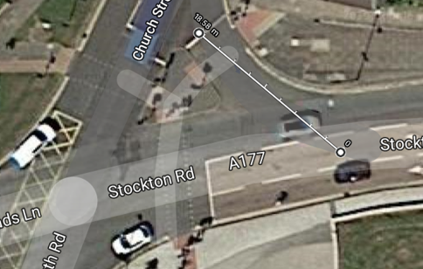

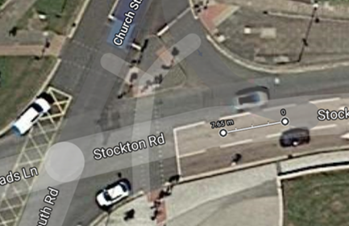

Fig 7g.

Fig 7h.

Table 1a. Demonstrates the accuracy of the distances calculated in the dense stereo approach

|  |  |  |  |  |  |
| --- | --- | --- | --- | --- | --- |
| **Figure** (Dense) | **Object** | **Distance Measured** | **Actual Distance** | **Difference** | **% Inaccuracy** |
| 6b | Van | 14.98 | 12.96 | 2.02 | +15.6 |
| 6b | Person (left) | 6.95 | 7.25 | 0.30 | -4.13 |
| 6b | Person (right) | 6.98 | 7.30 | 0.32 | -4.38 |
| 6c | Car | 12.73 | 11.83 | 0.90 | +7.61 |
| 6c | Truck | 22.42 | 20.33 | 2.09 | +10.28 |
| 6c | Person | 18.66 | 17.42 | 1.24 | +7.12 |
| 6e | Bus | 7.29 | 7.65 | 0.36 | -4.71 |
| 6e | Car | 2.93 | 4.11 | 1.18 | -28.47 |
| 6e | Truck (act. Bus) | 16.24 | 18.58 | 2.34 | -12.6 |
| **Total** |  |  |  |  | 10.54% |

**Comparison between Sparse and Dense Implementations:**

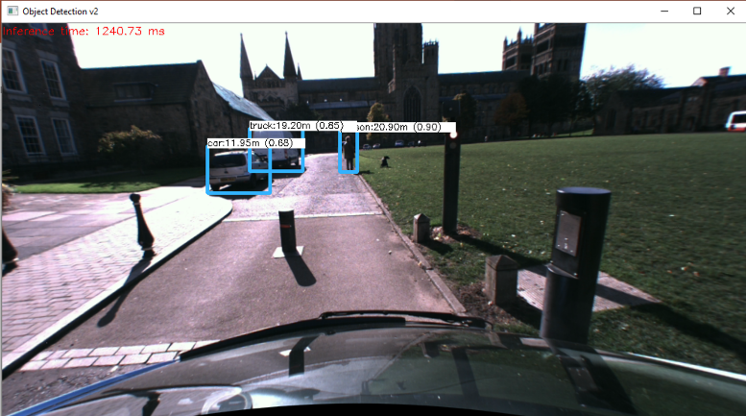The below images are the same as those in Fig. 6x, however, they have been applied to a sparse stereo algorithm rather than a dense, and the distance has been calculated simply through averaging the matched features.

Fig 8a.

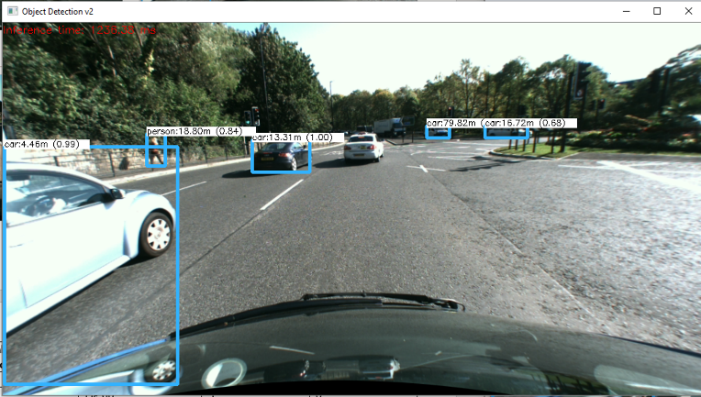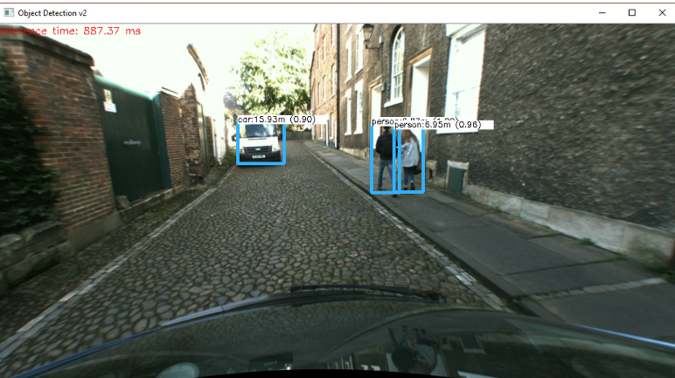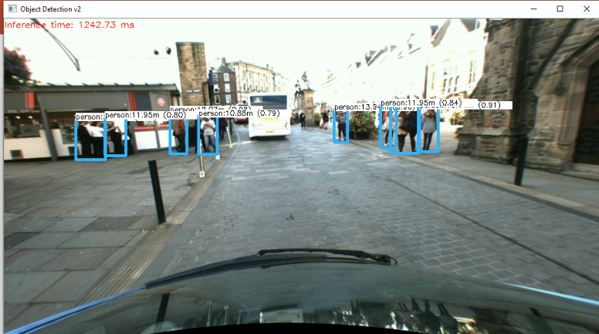

Fig 8b.

Fig 8d.

Fig 8c.

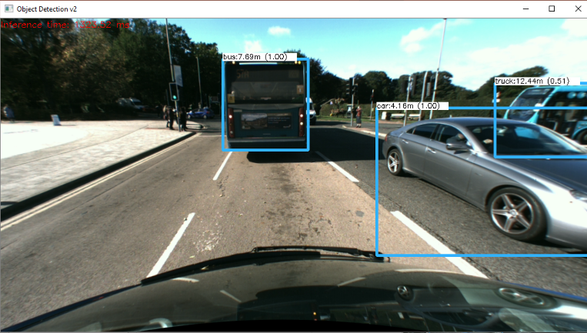

Fig 8e.

Table 2a. Demonstrates the difference in objects detected by each approach

|  |  |  |  |  |
| --- | --- | --- | --- | --- |
| **Sparse Image** | **Number of detected objects** | **Dense Image** | **Number of detected objects** | **Difference** |
| Fig 8a | 8 | Fig 6a | 10 | +2 **DENSE** |
| Fig 8b | 3 | Fig 6b | 3 | 0 |
| Fig 8c | 3 | Fig 6c | 3 | 0 |
| Fig 8d | 5 | Fig 6d | 6 |  |
| Fig 8e | 3 | Fig 6e | 3 | 3 |

Table 2b. Demonstrates the differences in distances calculated by each approach

|  |  |  |  |  |  |
| --- | --- | --- | --- | --- | --- |
| **Figure** (Dense) | **Object** | **Distance Measured** | **Difference** (to sparse) | **% Difference** (to sparse) | **% Inaccuracy** |
| 8b | Van | 15.93 | 0.95 | +6.14 | 22.92 |
| 8b | Person (left) | 6.97 | 0.02 | -0.29 | 3.86 |
| 8b | Person (right) | 6.95 | 0.03 | +0.43 | 4.79 |
| 8c | Car | 11.95 | 0.78 | 6.12 | 1.01 |
| 8c | Truck | 19.20 | 3.22 | 14.36 | 5.56 |
| 8c | Person | 20.90 | 2.24 | 12.00 | 12.00 |
| 8e | Bus | 7.69 | 0.4 | 5.49 | 4 |
| 8e | Car | 4.16 | 1.23 | 42.00 | 1.22 |
| 8e | Truck (act. Bus) | 12.44 | 3.8 | 23.40 | 32.94 |
| **Total** |  |  |  |  | 8.83% |

The tables above demonstrate that despite Sparse detecting less objects, it typically produces slightly more accurate distances. However, the incorrect values generated from sparse are generally worse, and as demonstrated in Fig. 8e it failed to calculate a distance accurately for an obstructed object. With a larger dataset I am not confident sparse would produce better results than dense.

**Fig 1a.**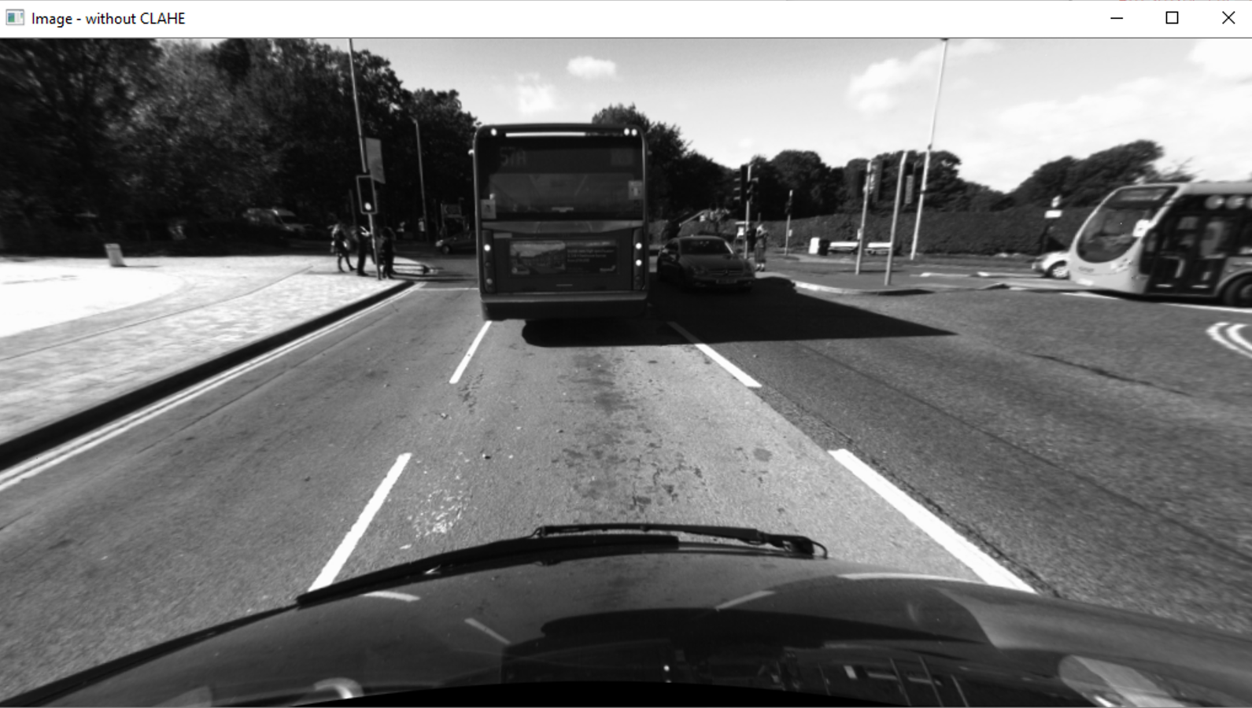

**Fig 1b**

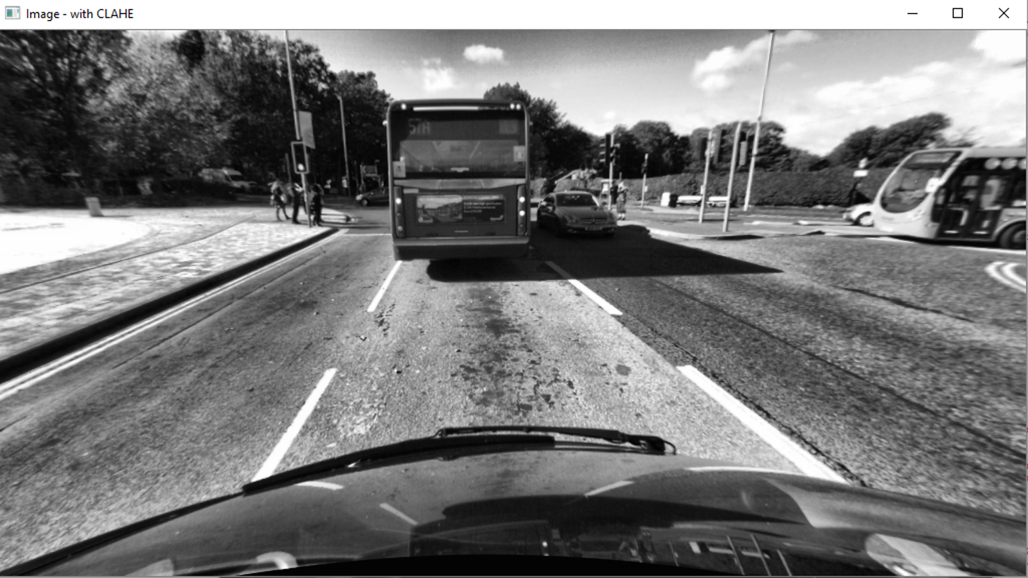

**Fig 2a**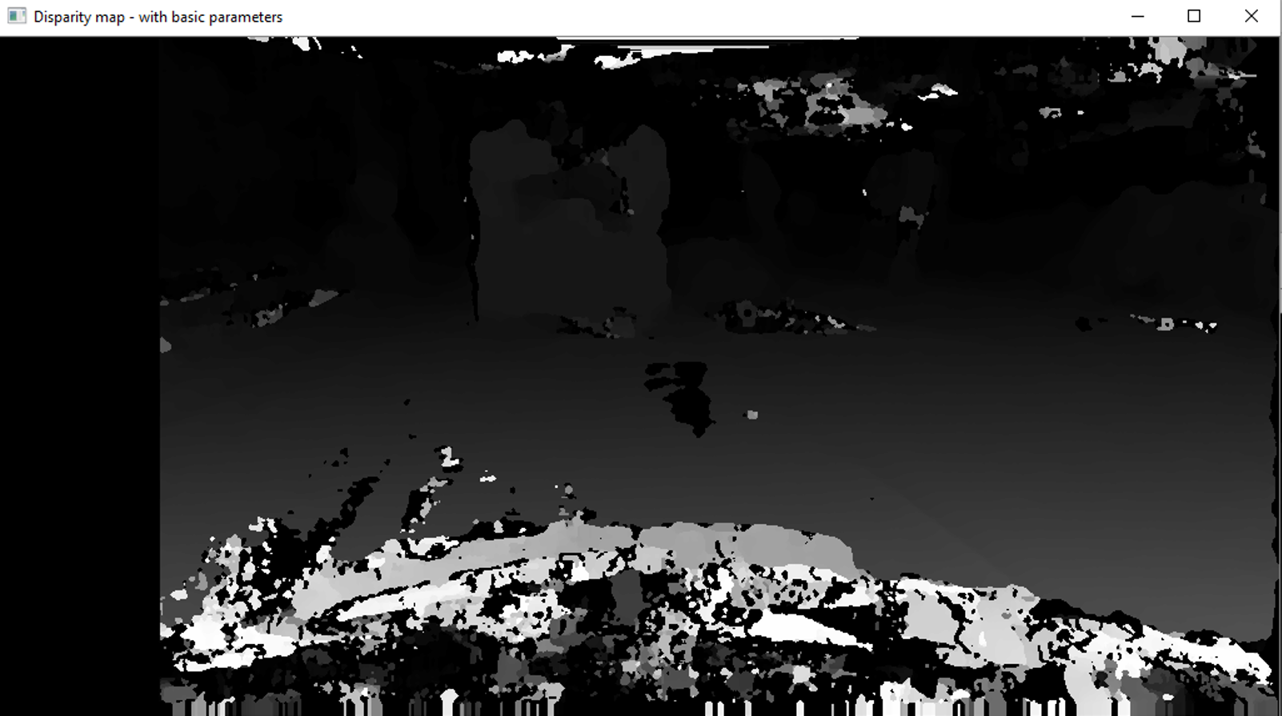

**Fig 2b.**

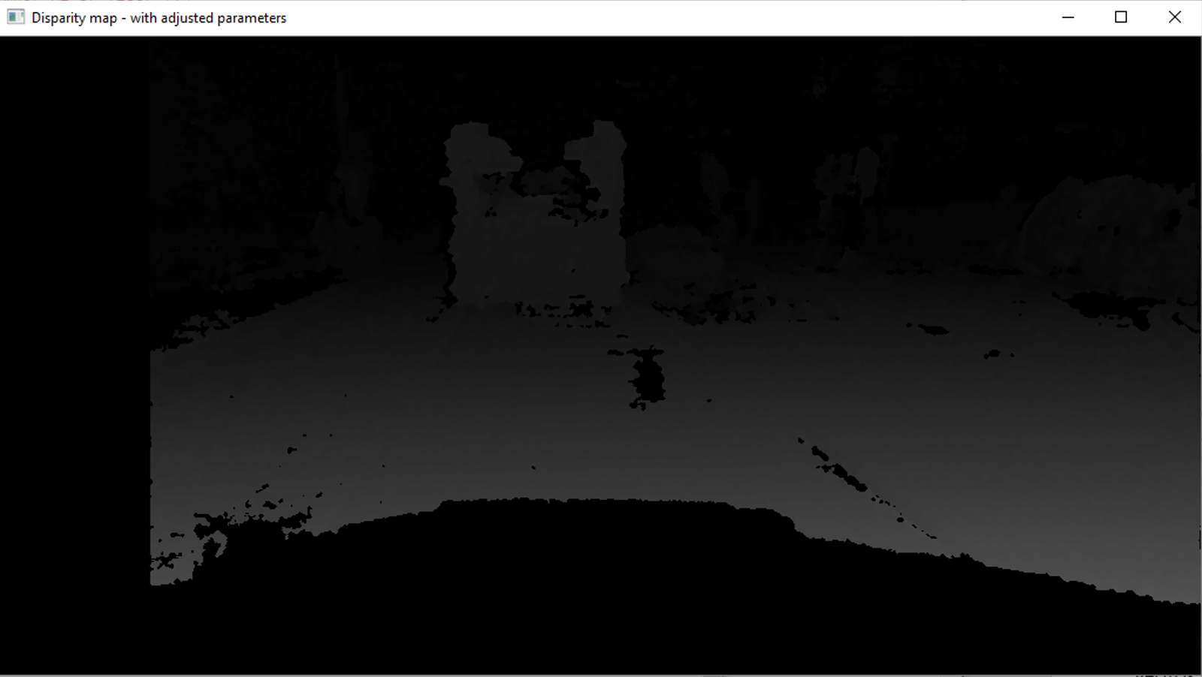

**Fig 3a.**

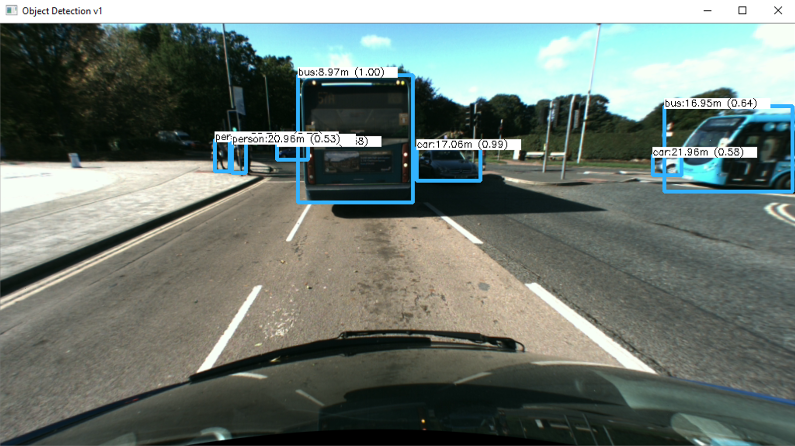

**Fig 3b.**

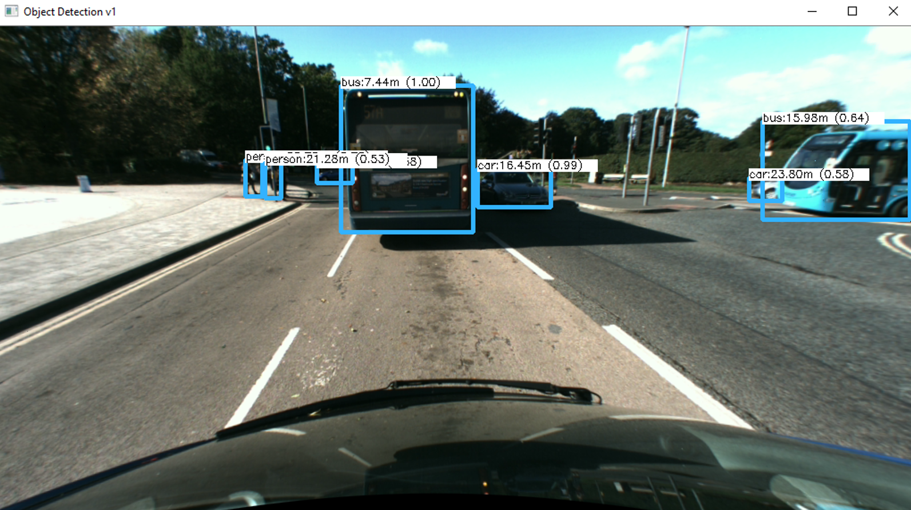

**Fig 3c.**

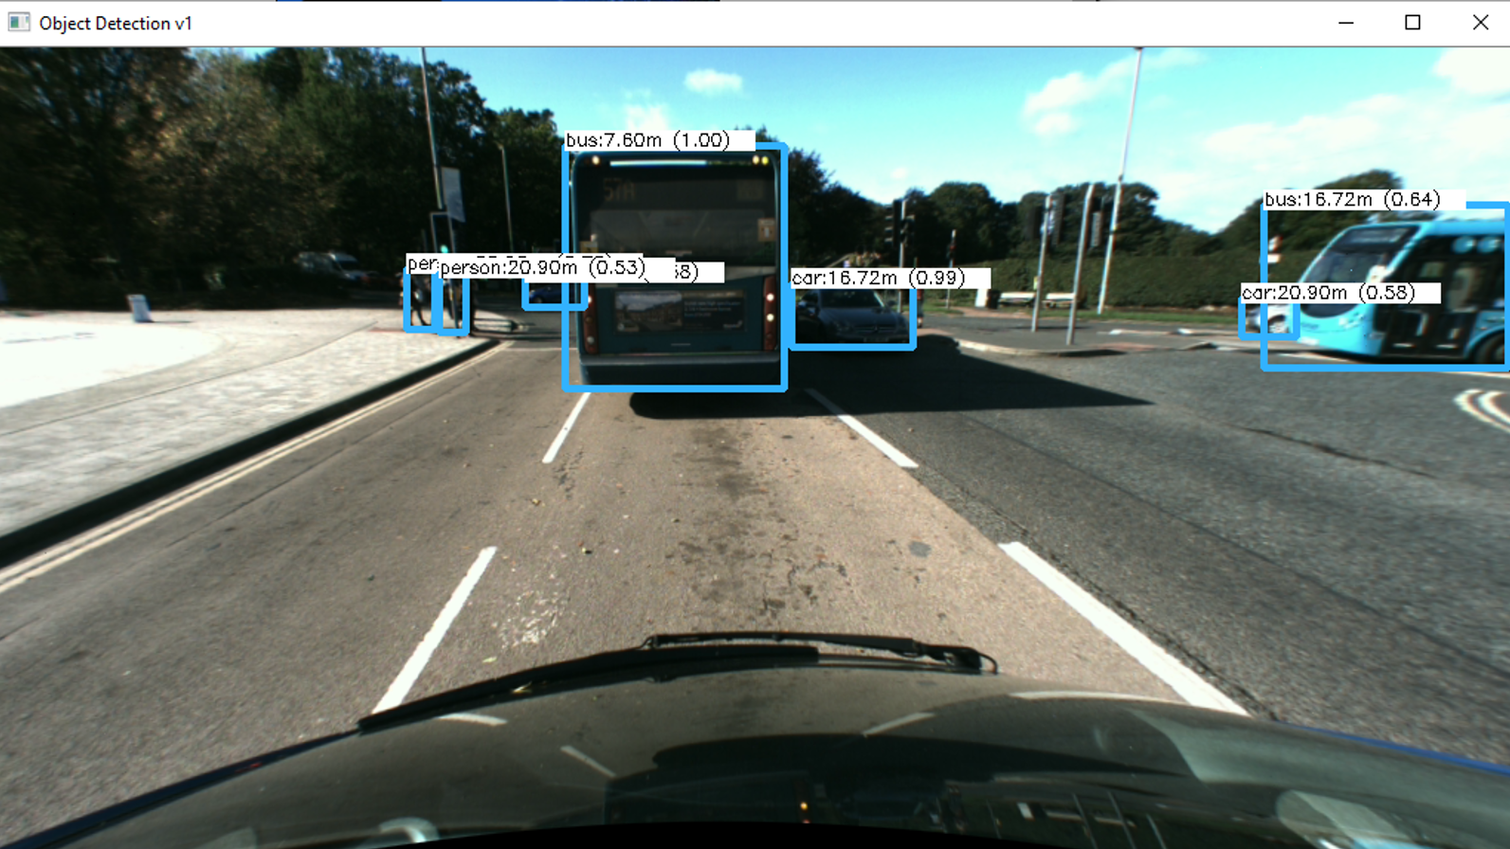

**Fig 3d.**

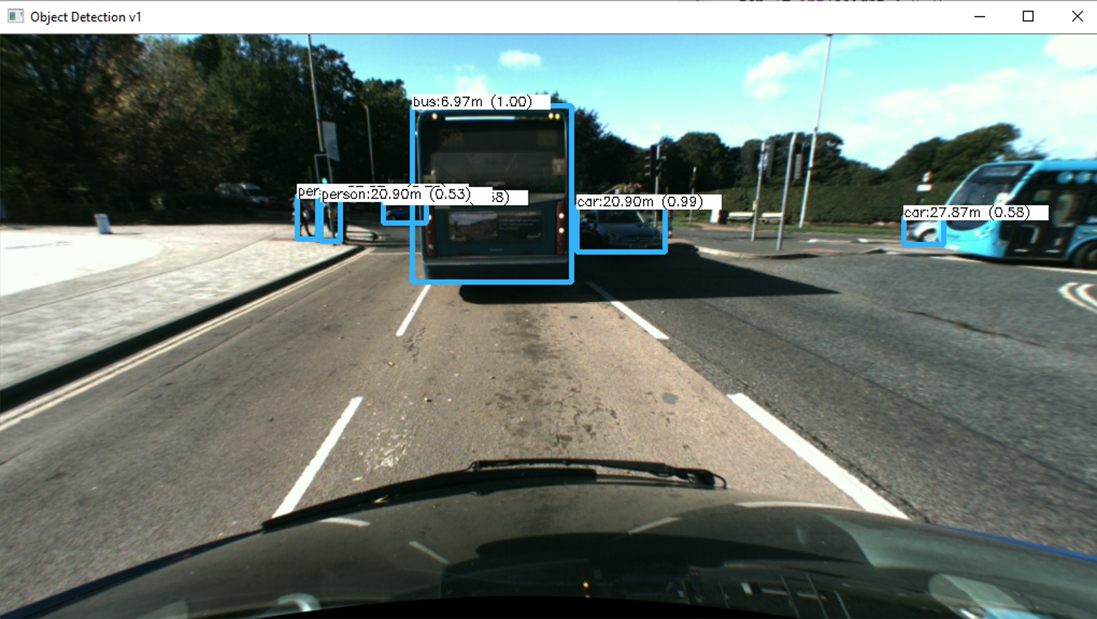

**Fig 4a.**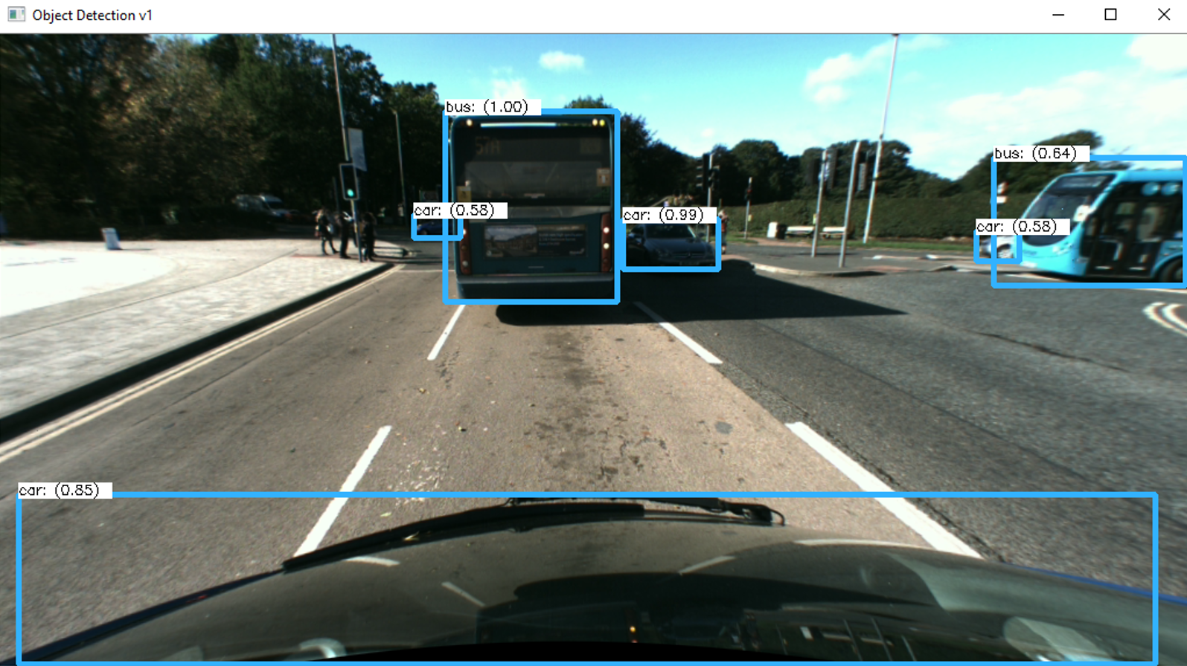

**Fig 4b.**

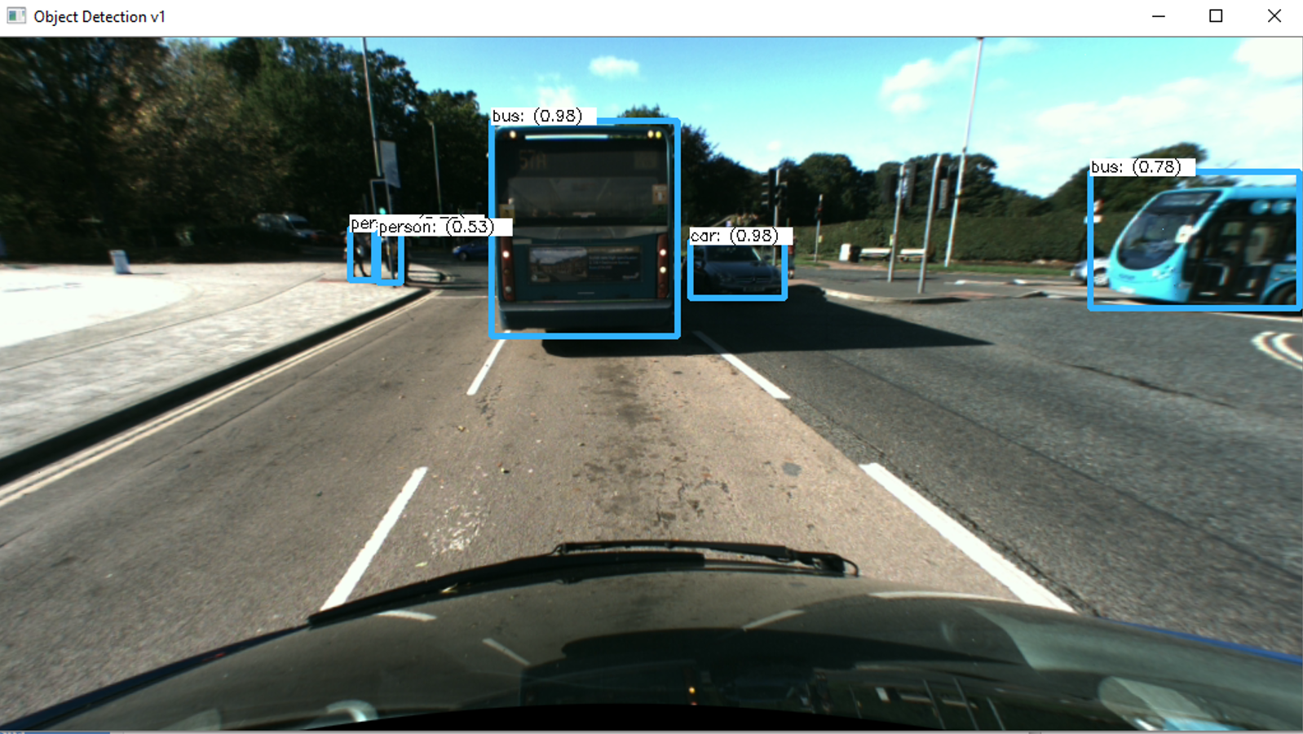

**Fig 4c**

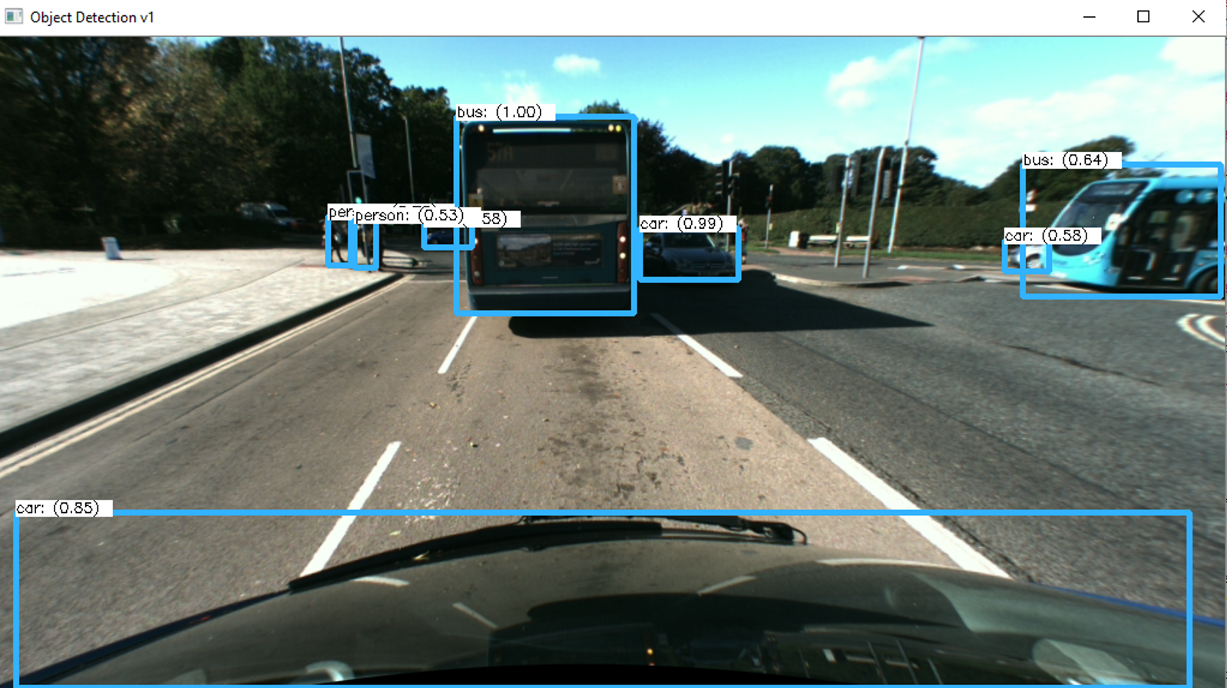

**Fig 5a**



**Fig 5b**

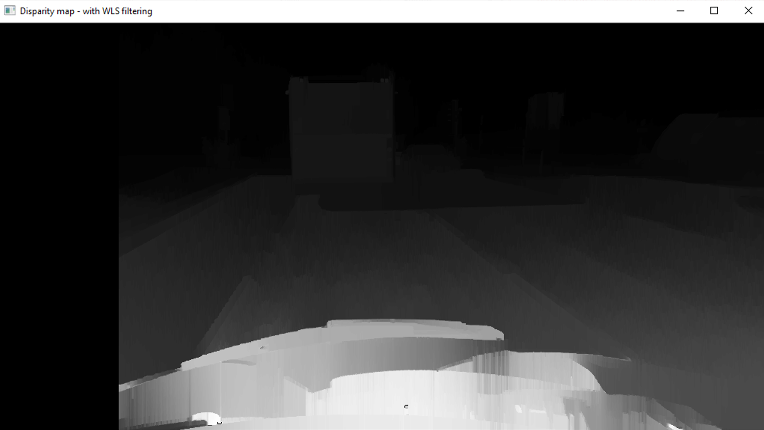

**Fig. 6a**

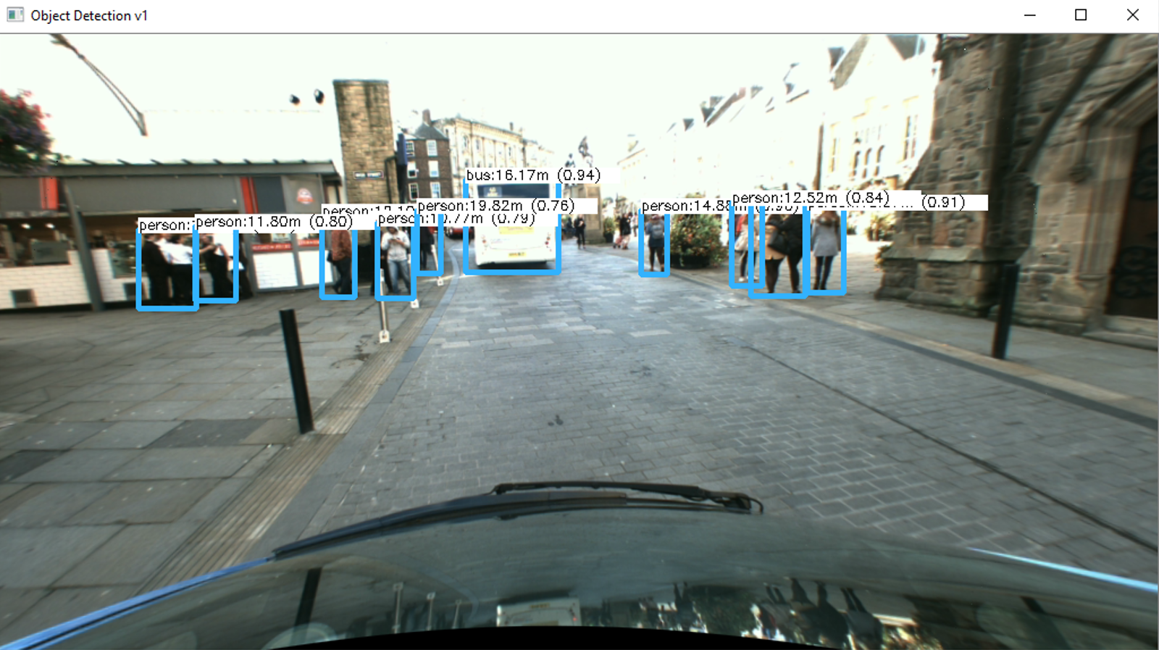

**Fig. 6b**

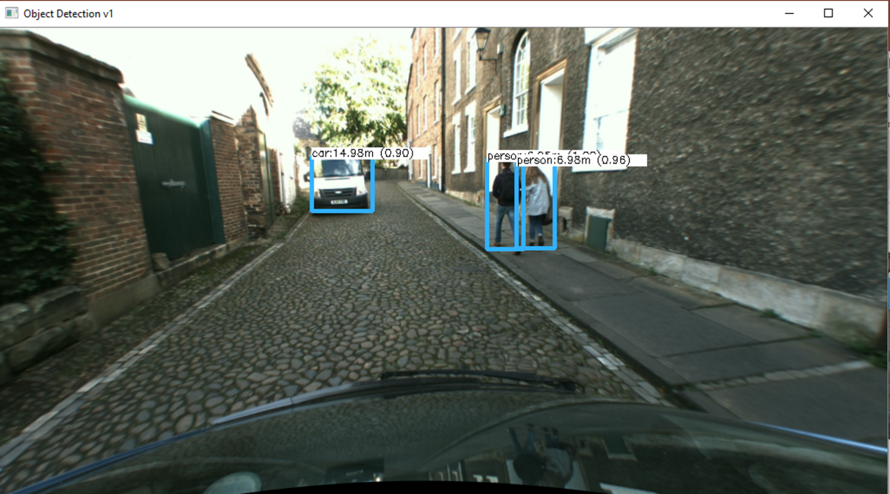

**Fig. 6c**

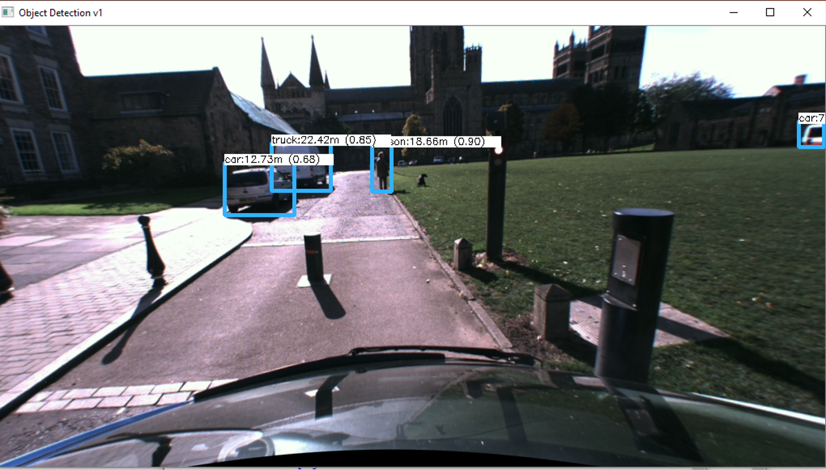

**Fig. 6d**

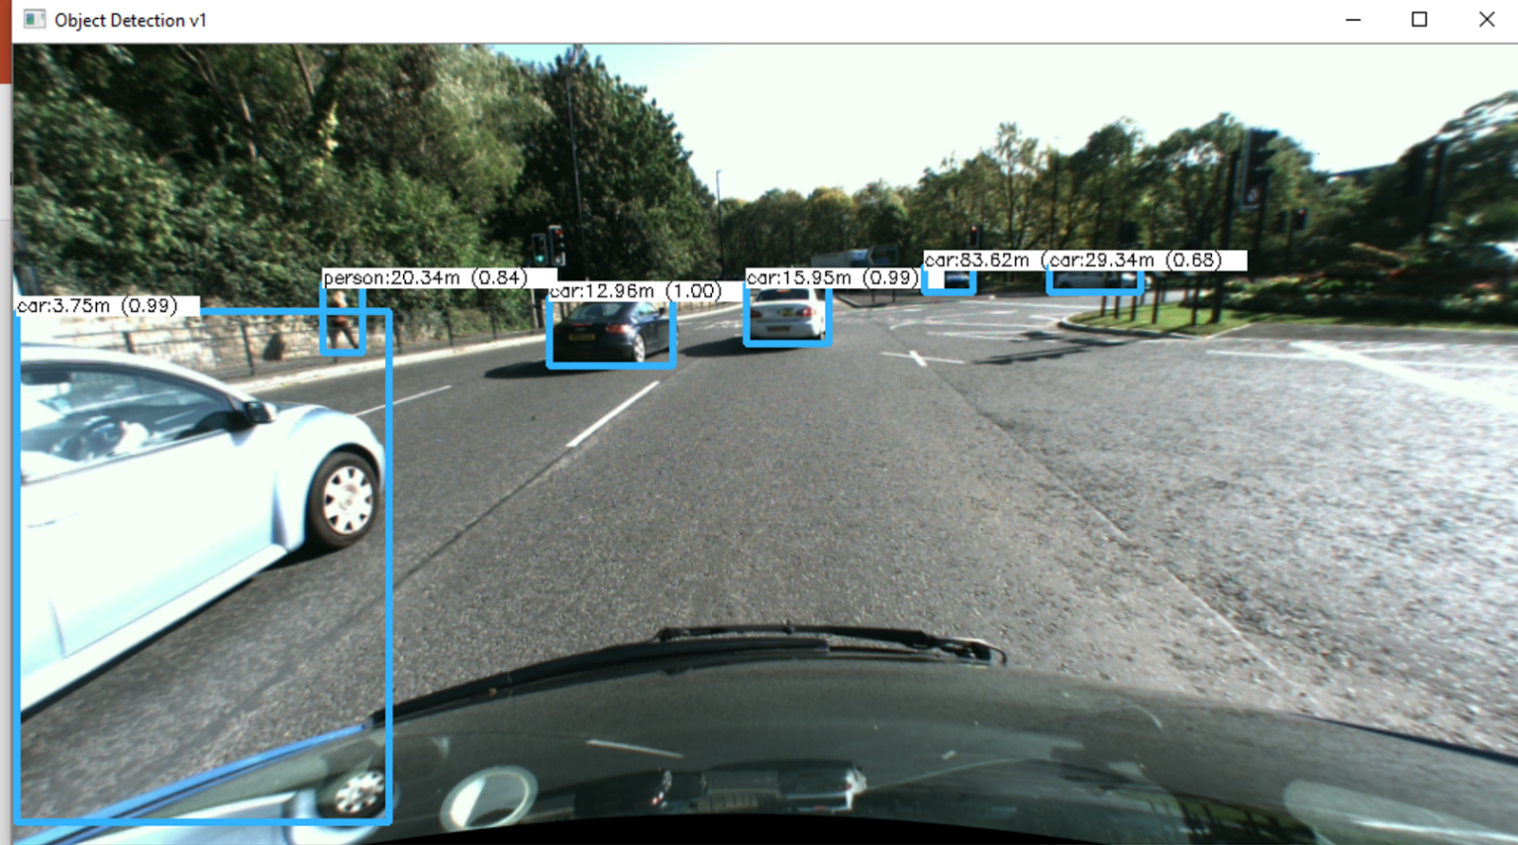

**Fig. 6e**

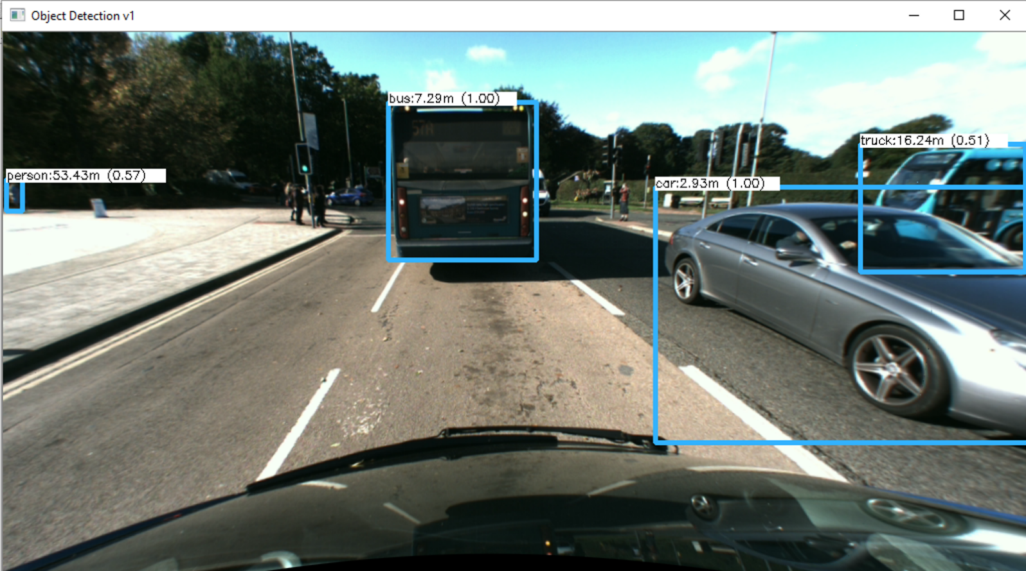

**Fig 7a**



**Fig 7b**



**Fig 7c.**

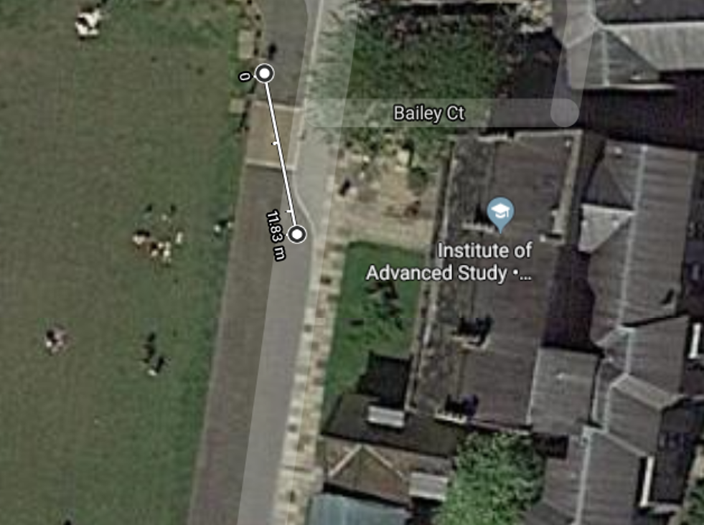

**Fig 7d**

**Fig 7e.**



**Fig 7f.**



**Fig 7g.**



**Fig 7h.**



**Fig 8a.**

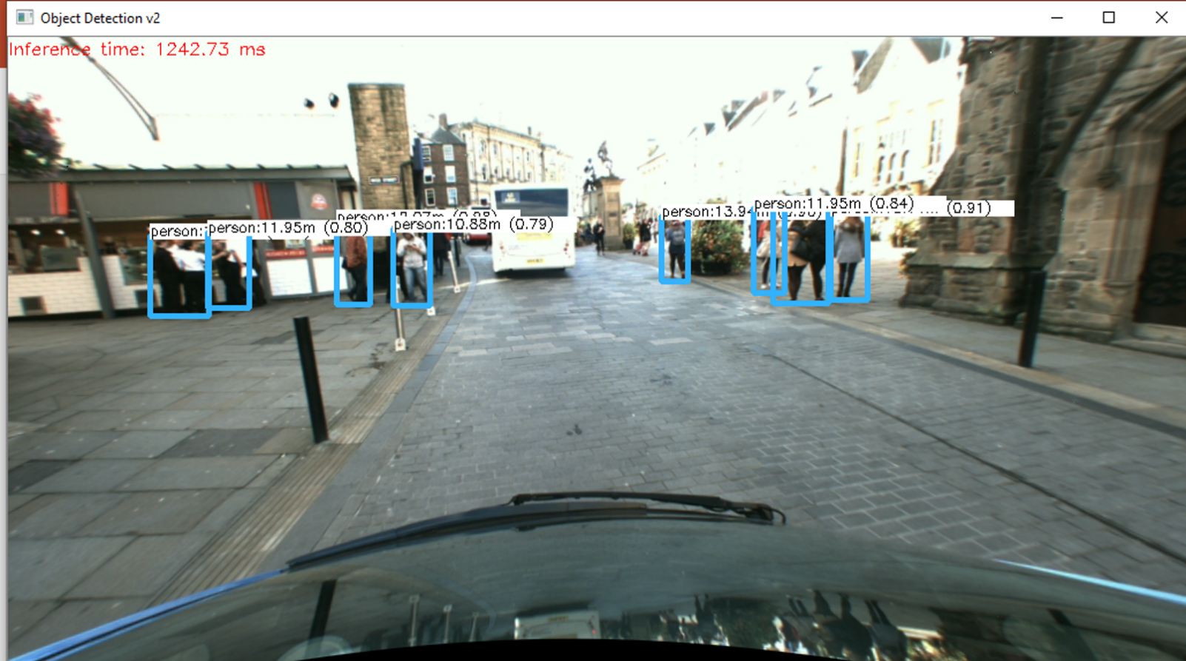

**Fig 8b.**

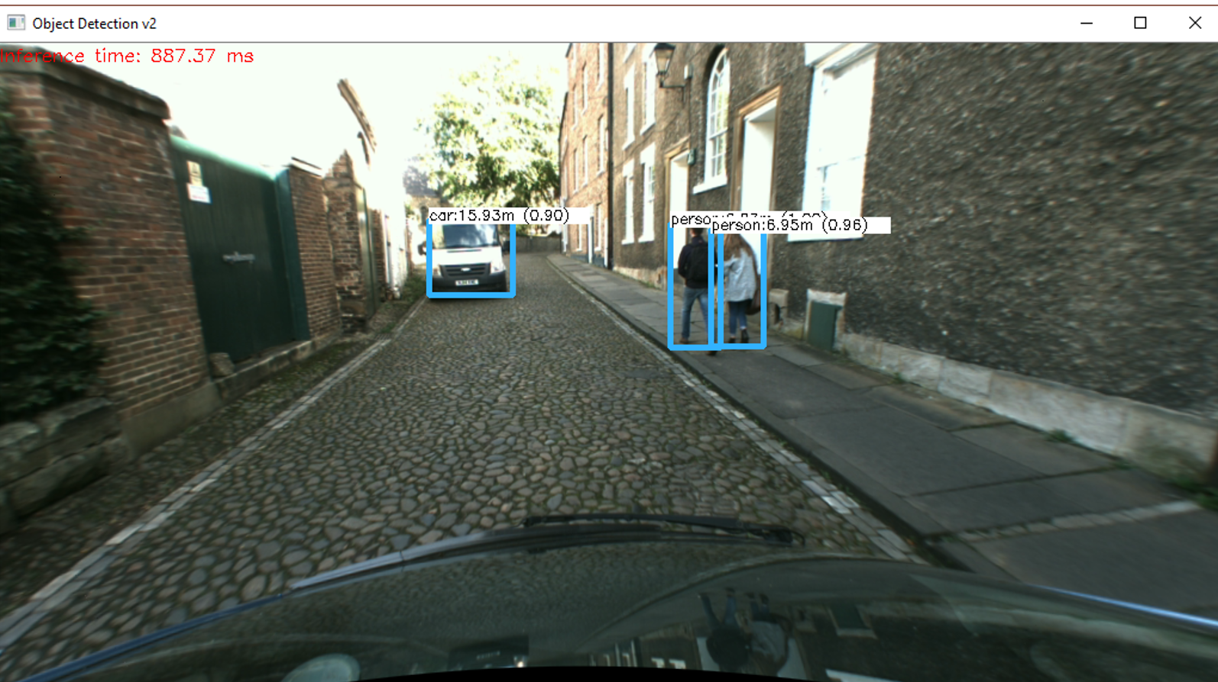

**Fig 8c.**

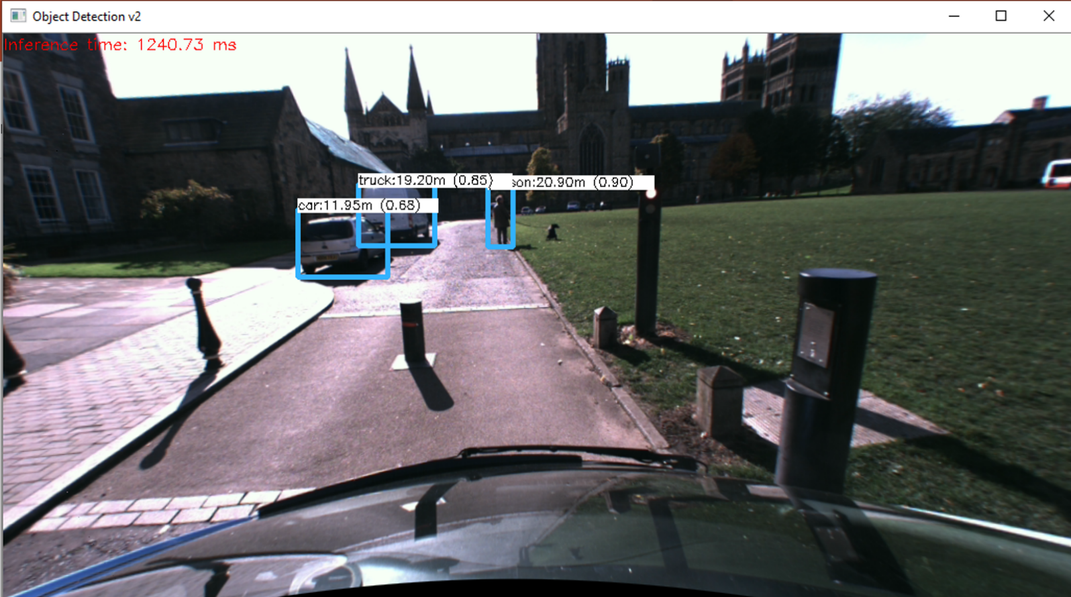

**Fig 8d.**

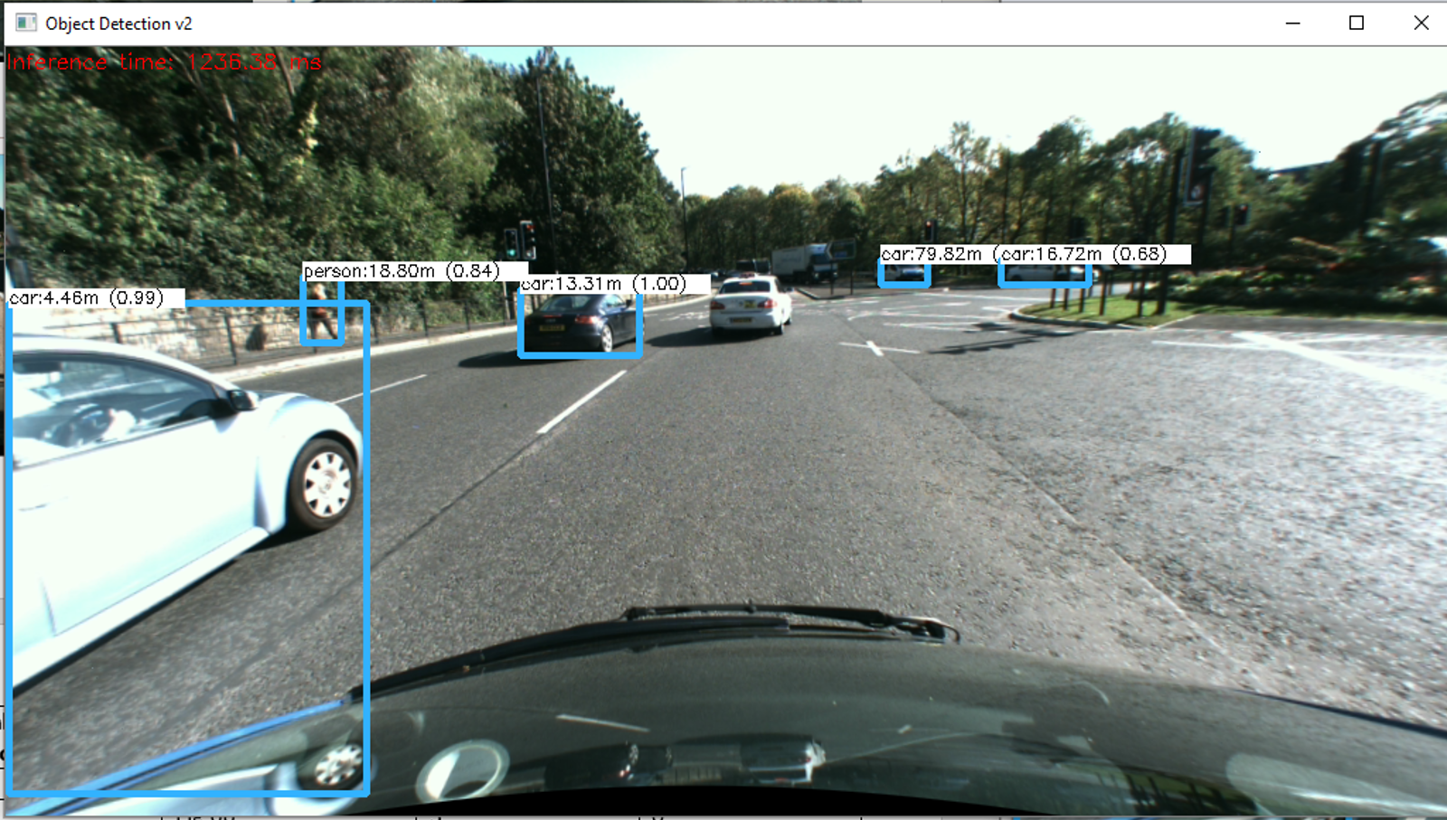

**Fig 8e**

